

American International University-Bangladesh (AIUB)  
**Department of Computer Science and Engineering   
Faculty of Science &Technology (FST)  
Fall 20-21  
CSC 00191- Object Oriented Analysis And Design (OOAD)**

**Section: I**

**Project Title: Personal Health Application**

**Submitted by:**

**Submitted to:**

**MD. ANWARUL KABIR**

**Sr. Assistant Professor**

**Department of Computer Science**

# *2. Project overview :*

In the personal health application, a citizen must complete the registration to use the application.Any Hospital can register their employees to serve the citizens. After completing the registration they can log in to the application by a password. By this application, citizens can check his/her profile .Can consult with any registered doctor by booking an appointment with the receptionist who will provide a serial number through this application. If the receptionist provides him/her serial number only then he/she can consult with a doctor. The doctor will check the citizen’s profile and provide a prescription for either or medicine or a test or operation depending on the health condition. A lab assistant will collect the sample to take the tests. The citizen can get the report from the receptionist afterward. The citizen can also donate blood to the blood bank through this application. Citizen can also collect blood from the blood bank if the necessity occurs. The citizen may pay the bill by cash or card to the accountant. The accountant will give clearance to citizens after receiving the money.

|  |  |
| --- | --- |
| **Actors** | Citizen, Blood Bank, Hospital Employee, Doctor, Receptionist, Lab Assistant, Accountant. |
| **Use Cases** | Registration, Password, Log In, Medicine, Test, Operation, Prescription, Check Profile, Consult with Doctor, Get Serial, Book Appointment, Report, Donate Blood, Receive Blood, Pay Bill, Take Test, Card, Cash, Give Clearance. |

1. ***Justification :***

The personal health application is a next-generation application that will help people to improve one’s health condition, self-management, and wellness by providing clear and complete medical details from the hospital. This application will help people to keep their medical records. The application will contain an individual’s health-related information accumulated during an entire lifetime. This application will reduce the complexities for a citizen of getting the appointment of doctors. It will also reduce the problem of carrying different types of files and reports. Citizens will also be able to get blood easily during their critical moments.

# *Overall Use Case of the Proposed Project :*

**Actors :** Citizen, Blood Bank, Hospital Employee, Doctor, Receptionist, Lab Assistant, Accountant .

**Use Cases :** Registration, Password, Log In, Medicine, Test, Operation, Prescription, Check Profile, Consult with Doctor, Get Serial, Book Appointment, Report, Donate Blood, Receive Blood, Pay Bill, Take Test, Card, Cash, Give Clearance.

***4.Use Case Diagram***

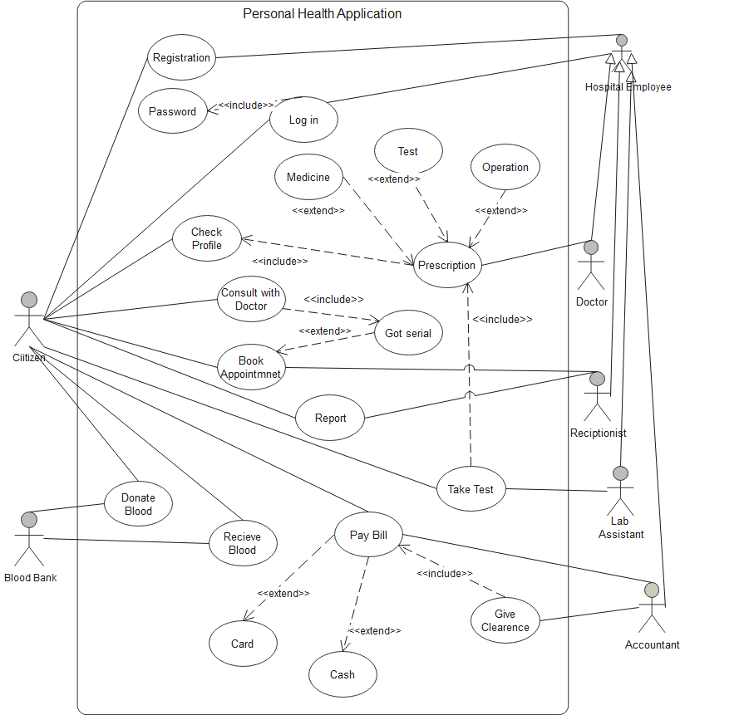

1. ***Class Diagam***

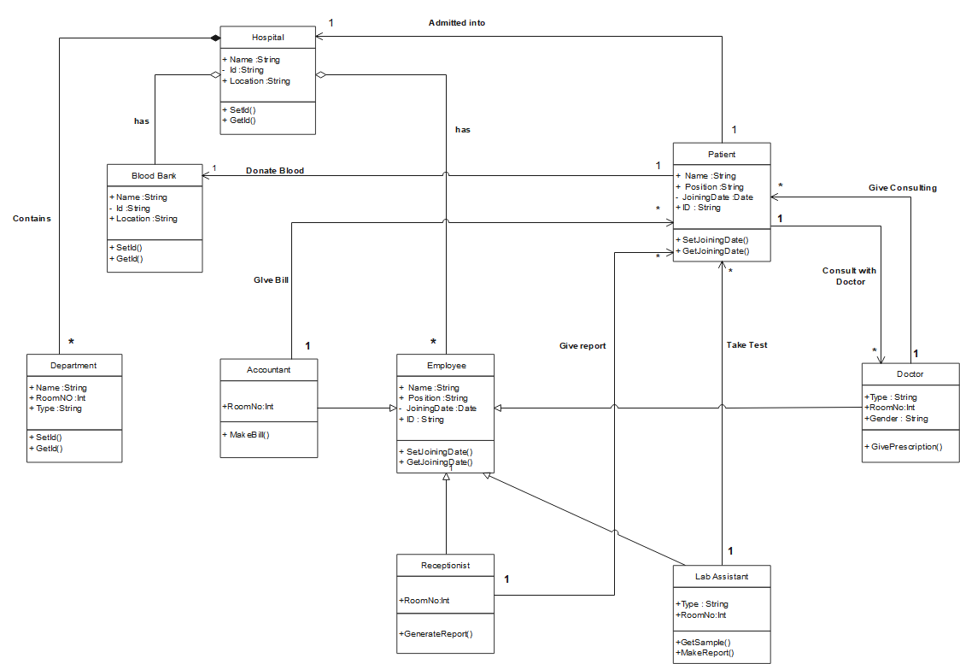

***6. Sequence Diagram***

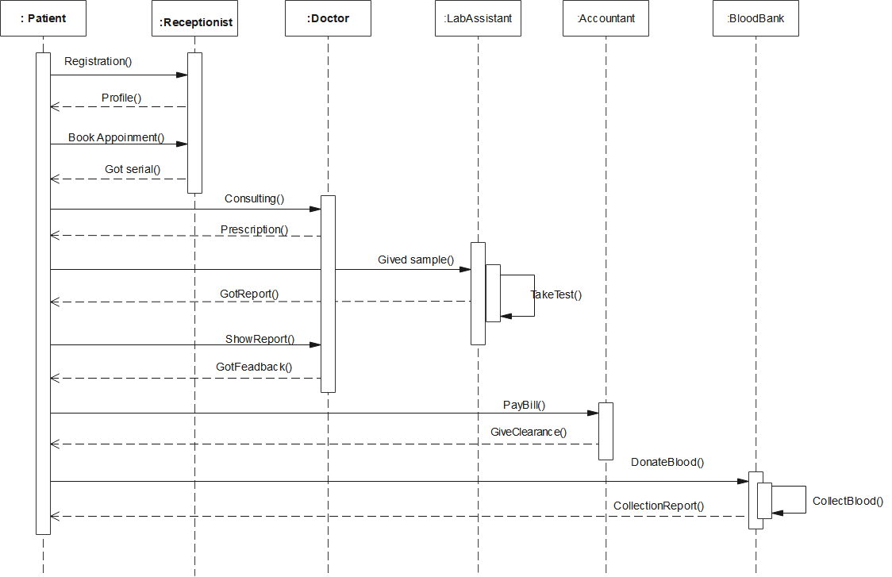

1. ***Activity Diagram***

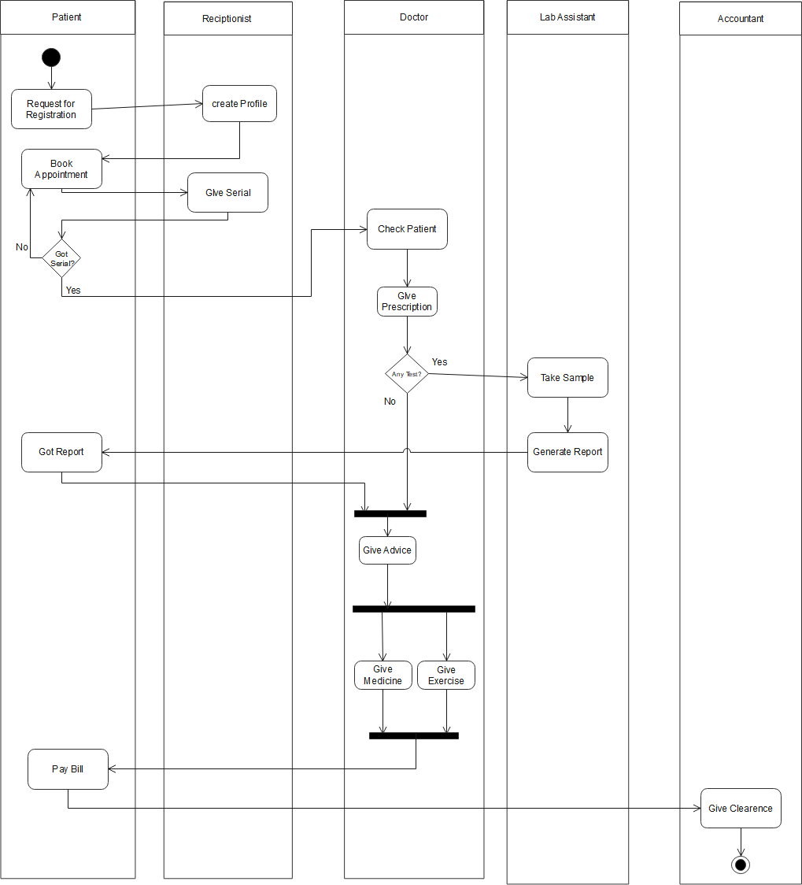

1. ***Statechart Diagram***

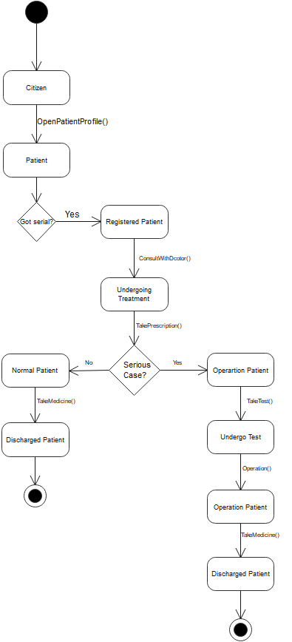

1. ***Conclusion :***

The personal health care system will make it easier for citizens to take proper care of their health. Citizens will get proper treatment quite easily. Their health will be observed smoothly by the health professionals. The system enables people to get proper advice from health professionals. People can get their health reports from anywhere and anytime. This system feature allows people to get those facilities. It will make the treatment hassle-free. The system features can also be upgraded in the future. In the future, this system is going to be a life-saving system for people.